**Taller 4**

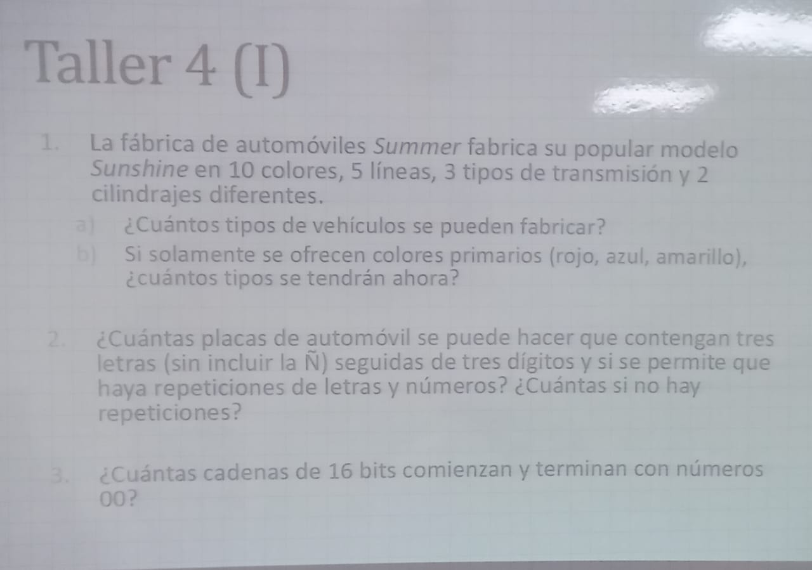

1. 10 x 5 x 3 x 2 = 300
2. 3 x 5 x 3 x 2 = 90



1. Si hay repeticiones = 26 x 26 x 26 x 10 x 10 x 10 = 17576000
2. Sin repeticiones = 26 x 25 x 24 x 10 x 9 x 8 = 11232000



1. 1 x 1 x 2**^**12 x 1 x 1=4096

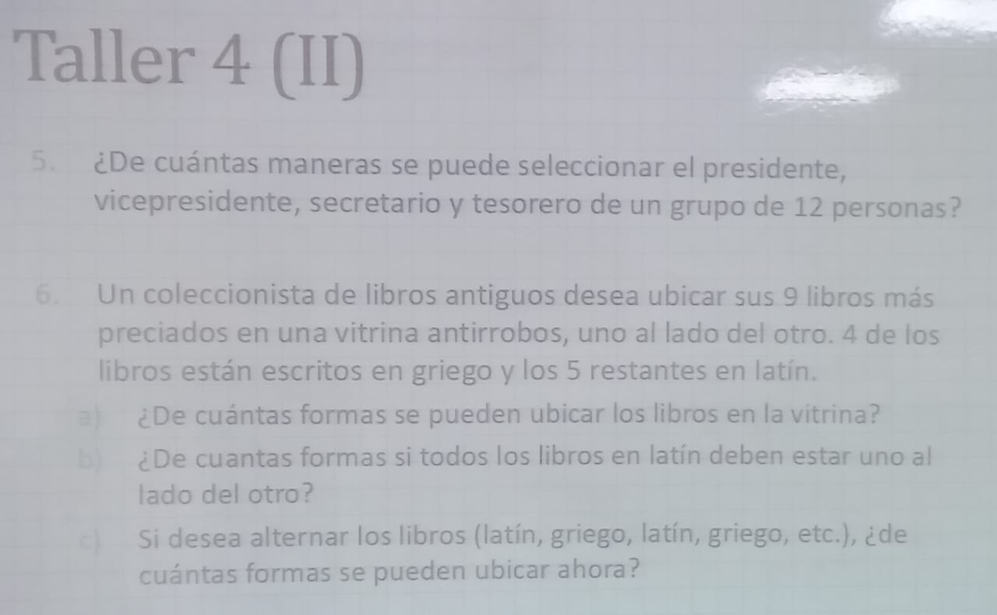

1. P(12,4) = $\frac{12!}{\left(12-4\right)!}=$ 11.880



1. 9! = 362.880
2. Paso1 (Latín) = 5! = 120

*

Paso 2 (Todos) = 5! =120 =14.400

1. 5! * 4! = 120*24 = 2880